3C-R9

3ngineering Club Robot 9roject

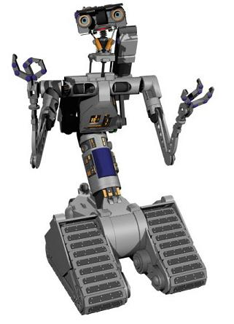

Mesa Community College Engineering club

Faculty Advisor: Bruce Carlton

Office: [PS 15](http://www.mesacc.edu/maps/southern-dobson-campus/15) - Room: 217

bruce.carlton@mesacc.edu